Plant Vogtle Units 3 & 4

Second Semi-Annual
Construction Monitoring Report

February 2010

Docket No. 29849-U

EXECUTIVE SUMMARY

This is the second semi-annual Vogtle Construction Monitoring report (“Second VCM Report”) submitted by Georgia Power Company (“Georgia Power” or “Company”) to the Georgia Public Service Commission (“Commission”) pursuant to the stipulation (“Stipulation”) adopted in the order in Docket No. 27800-U (“Certification Order”). Section 2(c) of the Stipulation requires such a report to be filed semi-annually.

One purpose of this Second VCM Report is to provide the basis upon which the Commission may verify and approve expenditures made pursuant to the certificate in accordance with O.C.G.A 46-3A-7(b). In this Second VCM Report, the Company requests that the Commission verify and approve $redacted that was invested in the construction of Plant Vogtle Units 3 and 4 (the “Project”) during the reporting period (July 1, 2009 through December 31, 2009). A total of $redacted has been invested in the Project to date. Of that, $redacted was approved and verified in the first semi-annual Construction Monitoring report (“First VCM Report”) proceeding just concluded.

Another purpose of this Second VCM Report is for this Commission to approve, disapprove, or modify any proposed revisions in the Project schedule and budget. In this Second VCM Report, the Company does not request any changes to the overall Project schedule or budget, except that the Company does specifically request that the Commission approve and verify Amendment No. 3 to the Engineering, Procurement and Construction (“EPC”) Agreement, which is more fully described in this Second VCM Report, and attached as Exhibit 1.

This executive summary provides an overview of the information contained in this Second VCM Report, and shows that construction of units 3 and 4 at Plant Vogtle (the “Units”) is on schedule and on budget, and demonstrates that cost pressures are being actively and prudently managed.

However, several key developments and issues should be highlighted to put the Project progress in context.

The Project remains on schedule. The Commission Staff and the Construction Monitor have been kept abreast of the progress of construction through their review of the level 1 schedule, which shows progress to date against the milestones. redacted redacted redacted redacted redacted redacted redacted redacted redacted redacted redacted redacted redacted redacted redacted redacted redacted redacted redacted redacted redacted redacted redacted redacted redacted redacted redacted redacted redacted redacted redacted redacted redacted redacted redacted redacted redacted redacted redacted redacted redacted redacted redacted redacted redacted redacted redacted redacted redacted redacted redacted redacted redacted redacted redacted redacted redacted redacted redacted redacted redacted redacted.

Pursuant to the Stipulation entered in the First VCM Report, the Company has reported against a revised certification amount of $6.113 billion. The change from the original amount of $6.4 billion is the result of the savings to be achieved by the adoption of the Georgia Nuclear Energy Financing Act (“SB31”), which provides for Construction Work in Progress (“CWIP”) to be included in rate base.

The forecasted Project continues to track under the $6.113 billion certified amount. As with any project of this magnitude, several individual items have increased while others have decreased, but the overall net change is favorable. The budget now contains increases to the Owners Cost to reflect the current estimates for emerging issues being monitored. These include redacted redacted redacted redacted redacted redacted redacted redacted redacted redacted, and other items. There has been a shift of approximately $redacted from Owners Cost to the EPC Cost as a result of EPC Amendment No. 2, which is attached as Exhibit 2.

These “line item” increases have been more than offset by the recent renegotiation of the escalation provisions of the EPC Agreement. The Commission will recall that at the time of certification, the EPC Agreement between Georgia Power, Oglethorpe Power Corporation, Municipal Electric Authority of Georgia and the City of Dalton (the “Owners”) and the Consortium, provided that the Consortium would design, engineer, procure, construct, and test two AP1000 nuclear units with electric generating capacity of approximately 1,100 megawatts each and related facilities, structures, and improvements at Plant Vogtle. The EPC Agreement is an arrangement whereby the Consortium supplies and constructs the entire facility with the exception of certain items provided by the Owners. Under the terms of the EPC Agreement, the Owners agreed to pay a purchase price that was to be subject to certain price escalations and adjustments, including certain index-based adjustments, as well as adjustments for change orders, and performance bonuses for early completion and unit performance.

As originally certified, redacted redacted of the Total Construction and Capital Cost was subject to escalation using redacted redacted redacted. redacted redacted of the Total Construction and Capital Cost was escalated using certain redacted redacted redacted, redacted redacted Owners Costs (non-EPC costs), and approximately redacted redacted. On February 22, 2010, Georgia Power, acting for itself and as agent for the Owners, and the Consortium entered into Amendment No. 3 to the EPC Agreement. Amendment No. 3, which is subject to the approval of the Commission, replaces certain index-based adjustments to the purchase price with fixed escalation amounts. Specifically, Amendment No. 3 redacted as an escalator and replaces it with a redacted redacted redacted. The result of this Amendment No. 3 is that now redacted redacted of the Project’s total construction and capital cost redacted. Of the EPC scope, redacted redacted redacted.

During the Certification proceedings, the Company had projected that escalation for the portion of the EPC work escalated redacted would be redacted redacted redacted. But, that estimate was subject to market forces and could have been much higher or lower depending on how the redacted performed over the life of the Project. Thus, customers bore the risk of inflation. Now, pursuant to Amendment No. 3, the redacted redacted of the EPC Agreement is now redacted at an amount projected to be redacted than projected under the former redacted escalation method.

The Current Forecast also reflects a reduction of $redacted in projected financing costs. This is a result of lower projected interest rates, timing changes in capital spending, and the expected benefits of the U.S. Department of Energy (“DOE”) loan guarantees. While not within the scope of this reporting period, it is noteworthy that on February 16, 2010, the DOE offered the Company a conditional commitment for federal loan guarantees that would apply to future Company borrowings related to Plant Vogtle Units 3 and 4. Any borrowings guaranteed by the DOE would be full recourse to the Company and would be secured by a first priority lien on the Company’s ownership interest in Plant Vogtle Units 3 and 4. Total guaranteed borrowings would not exceed 70% of eligible project costs, or approximately $3.4 billion, and are expected to be funded by the Federal Financing Bank. As a result of these guarantees, Georgia Power and its customers are expected to save approximately $15 million to $20 million in interest costs annually, at the corporate level, over the expected life of the bonds.

Georgia Power has 90 days to accept the conditional commitment, including obtaining any necessary regulatory approvals. The Company will work with the DOE to finalize the loan guarantees. Final approval and issuance of loan guarantees by the DOE are subject to receipt of the COL for Plant Vogtle Units 3 and 4 from the Nuclear Regulatory Commission (“NRC”), negotiation of definitive agreements, completion of due diligence by the DOE, receipt of any necessary regulatory approvals, and satisfaction of other conditions. There can be no assurance that the DOE will issue loan guarantees to the Company. It is also important to note that while the expected benefits of these federal loan guarantees have been reflected in the Current Forecast, the Current Forecast does not yet reflect any negative cost impacts that might result from the need to comply with federal regulations pertaining to entities that accept such federal loan guarantees.

Taking into consideration the revised upward budget for Owners Costs, the shift of scope from Owners Cost to EPC scope, the expected reduced financing costs, as well as the savings achieved by converting redacted to a redacted redacted redacted, the overall Project Current Forecast is $81 million below the $6.113 billion Certified Amount. While this $81 million represents a favorable variance, the Company does not recommend reducing the Certified Amount. The Company is still very early in the Project. The Company believes that this early budget under run bodes well for the prospects of keeping the final total cost at or below the Certified Amount, but cost pressures remain and the Company favors allowing the favorable variance to stay in place to work as a sort of contingency against future unexpected cost pressures.

As agreed in the Stipulation that was incorporated into the Certification Order, the Company responds to the 15 specified items, in the order in which they appear in Section 2(d)(1-15) of the Stipulation as follows:

- The reasons for any additional change in the estimated costs of the units since the process began.

In accordance with the Stipulation approved by the Commission in its Order approving the revisions and verifying the expenditures in Georgia Power’s First VCM Report, the Company will report against a total certified cost of $6.113 billion. This revised certified amount recognizes the effect of SB 31. The cost reports in the format agreed to in the Stipulation are provided in Tables 1.1 and 1.1a

Table 1.1
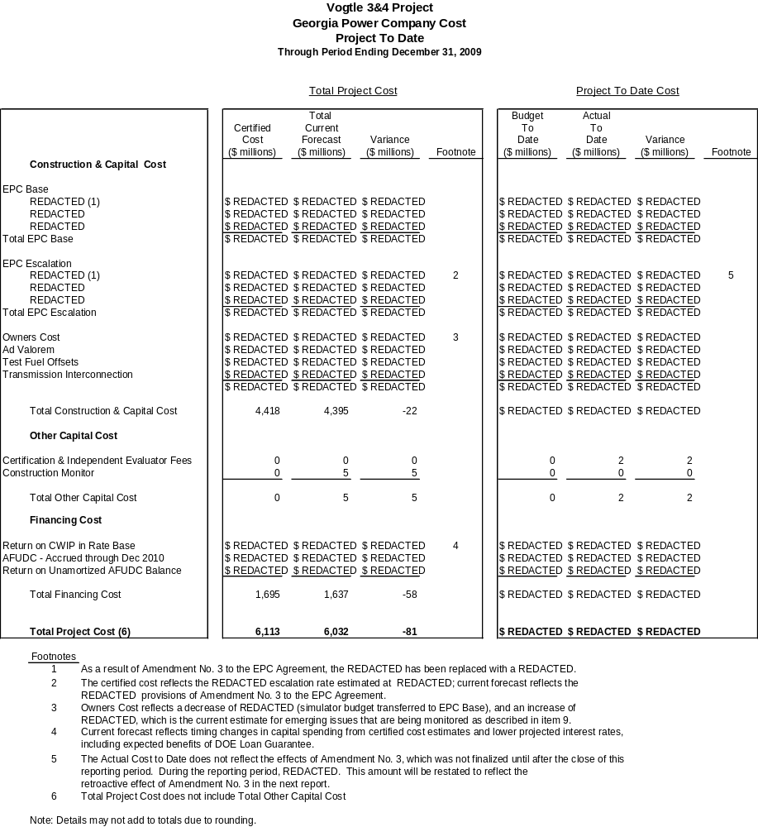

Table 1.1a (Trend)

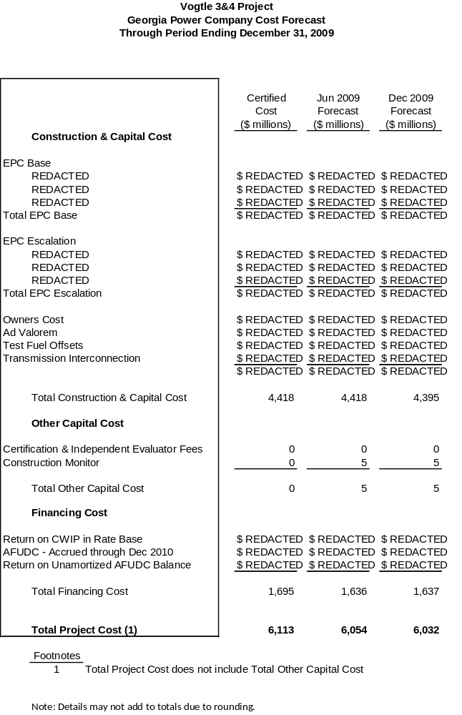
- A description of any cooperative actions between other builders of nuclear units in the southeast to address labor, crafts, engineering and management requirements.

Currently Southern Nuclear Operating Company (“SNC”) cooperates with other builders of nuclear units to address engineering and management requirements via industry related groups. These groups provide forums for builders of a given technology type to consider issues common to the participants, including development of training and development of standards for the labor pool. The groups operate under strict antitrust rules and do not collaborate in any way to influence the labor markets.

SNC, as a member of APOG, LLC, is currently working with Progress Energy Carolinas, Duke Energy Carolinas, Florida Power Corporation, South Carolina Electric and Gas Company to develop Knowledge and Ability training material required for NRC licensed operators program as well as development of common AP1000 operational programs required during pre and post operations.

SNC is also a member of NuStart Energy, a consortium of utilities and two reactor vendors whose purpose is to demonstrate the combined license (“COL”) process and complete design finalization activities for the two reactor technologies, Westinghouse AP1000 and General Electric ESBWR. Vogtle Units 3and 4 have transitioned to serve as the AP1000 Reference Combined License Application (“RCOLA”) and is a leader in both the licensing and engineering areas for the AP1000 utilities. The engineering team provides input to Westinghouse design finalization efforts and promotes standardization of site-specific design where practical.

The licensing team, also acting as the AP1000 Design Centered Working group, cooperates on the development of licensing material designated as standard content for the AP1000.

- An explanation of how the indices used in the EPC contract are tracking.

As originally certified, redacted redacted of the Total Construction and Capital Cost was subject to escalation redacted redacted redacted of the Total Construction and Capital Cost was escalated using redacted redacted redacted redacted represented Owners Costs (non-EPC costs), and redacted redacted redacted. On February 22, 2010, Georgia Power, acting for itself and as agent for the Owners, and the Consortium entered into Amendment No. 3 to the EPC Agreement. Amendment No. 3, which is subject to the approval of the Commission, replaces certain index-based adjustments to the purchase price with fixed escalation amounts. Specifically, Amendment No. 3 removes redacted as an escalator and replaces it with a redacted redacted redacted. The result of this Amendment No. 3 is that now redacted redacted of the Project’s total construction and capital cost redacted including redacted of the cost redacted redacted redacted. The only remaining index is the redacted, which is currently tracking redacted original estimates, as shown in Table 3.1.

Table 3.1

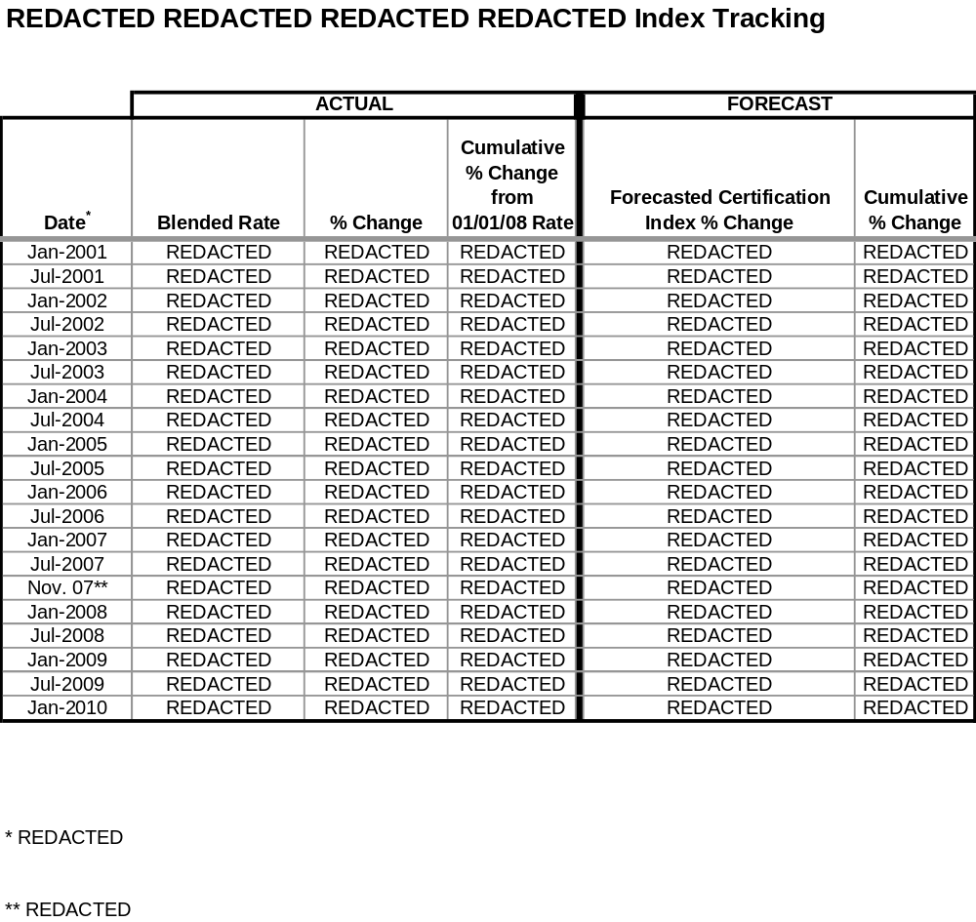

- Any updated estimate of on site spent fuel storage costs, including the costs for dry storage of spent fuel for an extended period of time after shutdown, and any updated calculation of spent fuel storage costs assuming Yucca Mountain is never available.

The Company provided a sensitivity analysis for spent fuel storage costs to the Commission Staff (“Staff”) and the Independent Evaluator in October 2008 that estimates the cost of on-site storage through 2088, which is ten years beyond the anticipated shutdown of Unit 4. There is no change at this time to the estimate provided in October 2008.

In November 2008, SNC executed a contract with the DOE that requires the DOE to complete removal of spent fuel from Vogtle Units 3 and 4 within ten years from the date of the shutdown of Unit 4.

- The status of the Company’s loan guarantee application at the Department of Energy and to the extent that application is granted, then the Company shall also report on the impact it has or would have on the final expected in-service cost of the units.

On February 16, 2010, Georgia Power received a conditional commitment for loan guarantees from the DOE that would apply to future Company borrowings related to Plant Vogtle Units 3 and 4. Total guaranteed borrowings would not exceed 70 percent of eligible project costs or approximately $3.4 billion.

Georgia Power has 90 days to accept the conditional commitment, including obtaining any necessary regulatory approvals. The Company will work with the DOE to finalize the loan guarantees. Final approval and issuance of loan guarantees by the DOE are subject to receipt of the COL for Plant Vogtle Units 3 and 4 from the NRC, negotiation of definitive agreements, completion of due diligence by the DOE, receipt of any necessary regulatory approvals, and satisfaction of other conditions. There can be no assurance that the DOE will issue loan guarantees to the Company.

As a result of these guarantees, Georgia Power and its customers are currently expected to save approximately $15 million to $20 million in interest costs annually, at the corporate level, over the expected life of the bonds. The actual amount of the interest savings will depend on the final terms and the timing of the specific borrowings. Loan Guarantees are conditioned upon receipt of the Vogtle 3 and 4 COL.

The estimated impact of the DOE Loan Guarantees on this Project is reflected in financing costs in Tables 1.1, 1.1a, and 8.1. While the expected benefits of these federal loan guarantees have been reflected in the Current Forecast, the Current Forecast does not yet reflect any negative cost impacts that might result from the need to comply with federal regulations pertaining to entities that accept such federal loan guarantees.

It is important to note that as a result of including CWIP in rate base during the construction period, in accordance with SB31, the ultimate in-service cost of the Units will not reflect the impact of either short-term or long-term debt financing.

- Whether the Company is using trust preferred financing and the impact it has or would have on the expected in-service cost of the units.

The Company has not issued trust preferred financing since 2004 and currently has no plans to do so. The Company does not currently view trust preferred financing to be an economic financing choice. The Company continues to monitor the security markets and rating agency treatment of these securities and will update its financial policies as needed in an effort to minimize overall financing costs for customers.

- The extent to which the Company is using short term debt and the impact it has or would have on the expected in-service cost of the units.

By prior Commission Order, the Company first applies its short-term debt balances towards financing of under-recovered fuel balances before directing the remaining balances to finance CWIP. During two months of 2009, short-term debt balances did exceed under-recovered fuel balances. Therefore, Allowance for Funds Used During Construction (“AFUDC”) booked in those two months did reflect the impact of short-term debt. As a result, total AFUDC booked on Vogtle Units 3 and 4 in these two months was approximately $redacted lower than it otherwise would have been. However, as a result of including CWIP in rate base during the construction period in accordance with SB 31, the ultimate in-service cost of the Units will not reflect the impact of either short-term or long-term debt financing.

- An update of the estimated in-service cost and projected date of commercial operation of both units.

An update of the estimated in-service cost of both Units is shown in Table 8.1 below.

The schedule approved in the Certification Order provides for a commercial operation date ("COD") for Unit 3 of April 1, 2016 and a COD for Unit 4 of April 1, 2017. The current project schedule projects a COD for Unit 3 in January 2016 and a COD for Unit 4 in January 2017.

Table 8.1

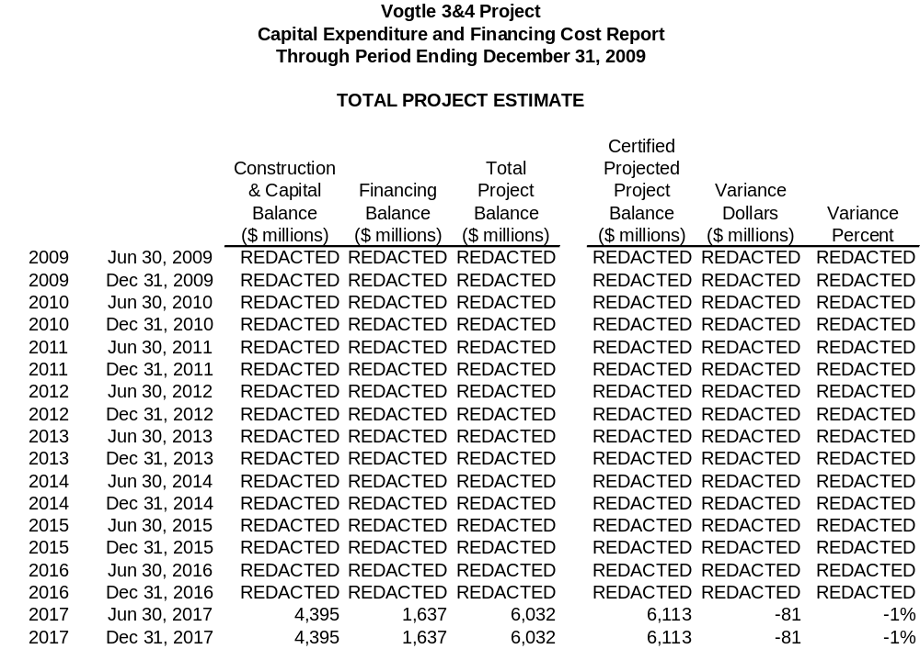

- A description of all major sources of changes (both increases and decreases) to the in-service cost and sources of change in commercial operation dates, if any.

In accordance with the Stipulation approving the revisions and verifying the expenditures in the Company’s First VCM Report, the Company will report against a certified Total Project Cost of $6.113 billion. This revised certified amount recognizes the effect of SB 31 as reflected on Table 1.1. The current total projected in-service capital cost for the Units is $4.395 billion and the current Total Financing Cost is $1.637 billion for a current Total Project Cost of $6.032 billion.

The major sources of decreases to the overall Total Current Forecast are set out in Table 1.1. The major sources of increases to the Owners Cost identified in Table 1.1 are related to emerging issues that are currently being monitored. Below is a description of the emerging issues that are the sources of increases to Owners Cost.

redacted redacted redacted redacted redacted redacted redacted redacted redacted redacted redacted redacted redacted redacted redacted redacted redacted redacted redacted redacted redacted redacted redacted redacted redacted redacted redacted redacted redacted redacted redacted redacted redacted redacted redacted redacted redacted redacted redacted.

redacted redacted redacted redacted redacted redacted redacted redacted redacted redacted redacted redacted redacted redacted redacted redacted redacted redacted redacted redacted redacted redacted redacted.

redacted redacted redacted redacted redacted redacted redacted redacted redacted redacted redacted redacted redacted redacted redacted redacted redacted redacted redacted redacted redacted redacted redacted.

redacted redacted redacted redacted redacted redacted redacted redacted redacted redacted redacted redacted redacted redacted redacted redacted.

Other Items Include:

redacted redacted redacted redacted redacted redacted redacted redacted redacted redacted redacted redacted redacted redacted redacted redacted redacted redacted redacted redacted redacted.

redacted redacted redacted redacted redacted redacted redacted redacted redacted redacted redacted redacted redacted redacted redacted redacted redacted redacted redacted redacted redacted redacted redacted.

redacted redacted redacted redacted redacted redacted redacted redacted redacted redacted redacted redacted redacted.

redacted redacted redacted redacted redacted redacted redacted redacted redacted redacted redacted redacted redacted redacted redacted redacted redacted redacted redacted redacted redacted redacted redacted redacted.

The following chart identifies projected cost increases related to the key sources of Owners Cost increases discussed above.

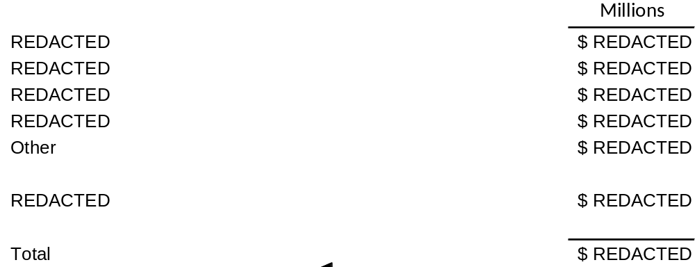

The cost projections provided within the table above are based upon the best information available at this time. The Company will continue to closely monitor these issues and revise projections as necessary in future reporting periods.

- The status of the Company’s combined construction and operating license (COL) application at the Nuclear Regulatory Commission.

Significant progress has been made in the last six months in the licensing of the Units. The Early Site Permit (“ESP”) was received in August 2009. This ESP also contained a Limited Work Authorization for certain safety-related construction to start at the facility prior to the receipt of the COL. The NRC Staff completed its detailed review on most of the Westinghouse DCD and the COL application material. In addition, the Advisory Committee for Reactor Safeguards Subcommittee has initially met and reviewed much of this material. For the DCD, the key remaining areas include the design of the shield building; downstream effects of the sump flow; and ongoing design changes emerging from design finalization. redacted redacted redacted redacted redacted redacted redacted redacted redacted redacted redacted redacted redacted redacted redacted redacted redacted redacted redacted redacted redacted redacted redacted redacted redacted redacted redacted redacted redacted redacted redacted redacted redacted redacted redacted redacted redacted redacted redacted redacted redacted redacted redacted redacted redacted redacted redacted redacted redacted redacted redacted redacted redacted redacted redacted redacted redacted redacted redacted redacted redacted redacted redacted redacted redacted.

Table 10.1
THROUGH DECEMBER 31, 2009
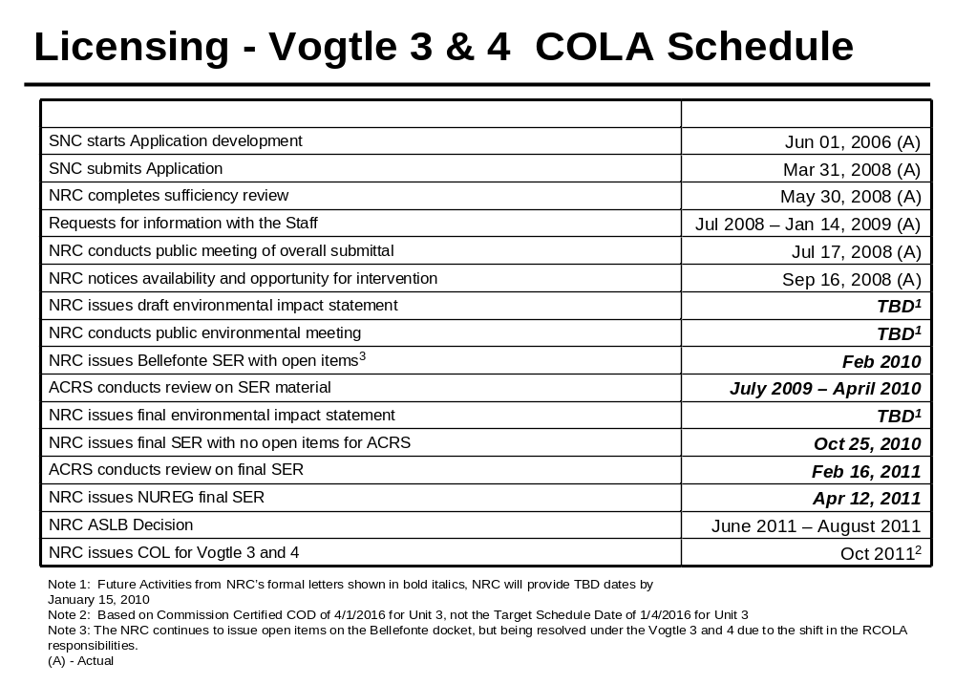
- The status of all other significant permits and licenses required from other governmental agencies.

Table 11.1

Permit | Activity Covered | Permitting Agency | Jurisdiction | Estimated Application Date | Projected Received Date | Required Date | Responsibility | Notes
Early Site Permit (ESP) and Limited Work Authorization (LWA) | ESP -Site approval for nuclear plant construction; LWA - approval for limited safety-related work | NRC | Federal | Actual August 2006 | Actual August 26, 2009 | redacted | SNC
Combined Operating License (COL) | Safety related construction for a nuclear power facility | NRC | Federal | Actual March 31, 2008 | redacted | redacted | SNC
Limited Work Authorization (LWA-B) | Approval for nuclear island rebar and embeds and placement of NI base slab | NRC | Federal | Actual October 2, 2009 | redacted | redacted | SNC
Section 404 Permit | Disturbance of crossing wetland areas or navigable waters | USACE | Federal | Actual  November 9, 2009  Revised January 7,2010 | redacted | redacted | SNC | 1,7,8, 16
Section 10 Permit | Barge slip, new intake/discharge to Savannah River | USACE | Federal | Actual  November 9, 2009 Revised January 7,2010 | redacted | redacted | SNC | 1,7,8, 16
Section 401 Certification | Compliance with water quality standards | GDNR | State | Actual  November 9, 2009 Revised January 7,2010 | redacted | redacted | SNC | 7,8,16
State Waters Buffer Variance | Land disturbing activities within 25’ state waters buffer | GDNR | State | Actual  January 8, 2010 | redacted | redacted | SNC
Certificate of Registration | Transportation of Hazardous Material | USDOT | Federal | Actual May 2009 | Actual May 14, 2009 | redacted | SNC
Federal Depredation Permit | Adverse impacts on protected species and/or their nests. For site and rail corridor upgrade. | USFWS | Federal | If needed | TBD | TBD | SNC/GPC | 13
Scientific Collecting Permit | Collection of specimens | USFWS | Federal | If needed | TBD | TBD | SNC/GPC | 13
Salvage Permit | Donation or receipt of protected species (bodies, feathers, etc.) for exhibit or scientific study | USFWS | Federal | If needed | TBD | TBD | SNC/GPC | 13
Objects Affecting Navigable Airspace -  Construction Notice | Notice of erection of structures (>200’ high) potentially impacting air navigation | FAA | Federal | redacted | redacted | redacted | Shaw
Stand-Alone Construction Projects Storm Water Permit | Discharge storm water from site during construction | GDNR | State | Actual October 2008 | ongoing | Various | SNC
National Historic Preservation Act | Consultation regarding potential to adversely affect historic resources | GDNR | State | Letter to SHPO transmitting MOU for signature  Actual December 2009 | redacted | redacted | SNC | 7, 9, 17
Air Quality Construction Permit | Construction air emission sources | GDNR | State | Actual March 13, 2009 | Actual June 18, 2009 | redacted | Shaw | 10
NPDES Wastewater Permit | Regulates limits of pollutants in liquid discharge to surface water | GDNR | State | Actual September 23, 2009 | redacted | redacted | SNC | 2,7
Air Quality Construction Permit | Construction of plant air emission sources | GDNR | State | Actual May 22, 2009 | redacted | redacted | SNC
GA Endangered Wildlife Act | Adverse impacts on state designated protected species and/or their habitat. For site and rail corridor | GDNR | State | If needed | TBD | TBD | SNC | 13
NPDES Wastewater Permit | Regulates limits of pollutants in liquid discharge to surface water | GDNR | State | TBD | TBD | 2015 | SNC | 3, 14
NPDES Wastewater Permit | Regulates limits of pollutants in liquid discharge to surface water | GDNR | State | TBD | TBD | 2016 | SNC | 3, 14
Infrastructure Projects Construction Storm Water Permit | Discharge storm water from linear construction sites (e.g. Roadways, transmission line and rail corridor) | GDNR | State | TBD | TBD | redacted | GPC | 14
General Permit for Industrial Storm Water Discharges | Discharge storm water associated with industrial activity | GDNR | State | TBD | TBD | redacted | SNC | 4, 14
Permit to Operate a Public Water System | Operate a public, non-transient, non-community water system | GDNR | State | Actual June 16, 2009 | redacted redacted redacted redacted | TBD | SNC | 4,15
Permit to Operate a Public water System | Operate a public, non-transient, non-community water system | GDNR | State | Actual September 9, 2009 | redacted redacted redacted redacted | redacted | SNC | 12
Permit to Withdraw Groundwater – Make up Wells 3 and 4 | Consumptive use of 100,000 gallons per day or more of groundwater | GDNR | State | Actual May 26, 2009 | Actual July 30, 2009 | redacted | SNC | 4
Permit to Withdraw Groundwater – Dewatering Activities | Dewater for foundation if needed for more than 60 days | GDNR | State | Actual  September 3, 2008 | Actual March 27, 2009 | redacted | SNC
Certificate of Abandoned Well(s) – MU-2A | Abandoned wells have been filled, plugged and sealed (notification required 30 days after well is abandoned) | GDNR | State | 2011 | N/A No response required | redacted | SNC | 11
Certificate of Abandoned Well(s) – SW-5 | Abandoned wells have been filled, plugged and sealed (notification required 30 days after well is abandoned) | GDNR | State | Actual February 18, 2009 Notification only | NA – No response required | NA | SNC
Permit to Withdraw Surface Water | Surface water withdrawal | GDNR | State | redacted | redacted | redacted | SNC | 4
Land Disturbing Activity Permit | Permission to conduct land disturbing activities of one acre or larger, or within 25’ of any state waters | GDNR | State | N/A | N/A | N/A |  | 5
Private Industrial Landfill Permit | On-site disposal of solid waste consisting of construction and demolition debris | GDNR | State | Actual December 2008 | Actual Revised D & O Plan Received April 30, 2009 | redacted | SNC | 4
Solid Waste Handling Permit | Disposal of industrial solid wastes. Transportation of putrescible waste for disposal in a permitted landfill | GDNR | State | N/A | N/A | N/A | SNC | 6
Title V Operating Permit | Operation of air emission sources | GDNR | State | TBD | redacted | redacted | SNC | 4, 14
Certificate of Public Convenience and Necessity | Present and future public convenience and necessity requiring the operation of such equipment or facility | GA PSC | State | Actual August 1, 2008 | Actual March 17, 2009 Approved by PSC | redacted | GPC
General Permit to Transport Radioactive Materials | Transportation of radioactive materials in the State of Georgia | GDNR/  GDPS | State | TBD | redacted | redacted | SNC | 4, 14
Utility Right-of-Way Permit | Utility right-of-way easement | GDOT | State | TBD | redacted | redacted | GPC | 14
Tennessee Radioactive Waste License-for-Delivery | Transportation of radioactive materials into the State of Tennessee | TDEC | State | TBD | redacted | redacted | SNC | 4, 14
Utah Radiation Control Rule | Transportation of radioactive materials into the State of Utah | UDEQ | State | TBD | redacted | redacted | SNC | 4, 14
Scientific Collecting Permit | State permit for collection of specimens | SCDNR | State | If needed | TBD | TBD | SNC/GPC | 13
Scientific Collecting Permit | State permit for collection of specimens | GDNR | State | If needed | TBD | TBD | SNC/GPC | 13
Land Disturbing Activity Permit | All land disturbing activities within the boundaries of Burke County | Burke County | County | N/A | N/A | N/A | N/A | 5
Building Permit | Construction, alteration, repair, or demolition of any building or structure within the boundaries of Burke County | Burke County | County | N/A | N/A | N/A | N/A | 5
Demolition Notification | Notice of demolition of buildings or structures | GDNR/  Burke County | State/  County | Various – first notification submitted in October 2008 | Various | Various | SNC
Land Disturbing Activity Permit | All land disturbing activities within the boundaries for transmission construction | Various | County | N/A | N/A | N/A | N/A | 5

Notes on Variances
1 | Permit application to be submitted in accordance with USACE regulations. Corps Master permit to cover barge slip, intake and discharge
2 | If needed for Batch Plant
3 | Modification to existing permit – one for Unit 3 and one for Unit 4
4 | Modification to existing permit; early filing planned pending receipt of intake design from Shaw
5 | Not applicable since GPC is exempt pursuant to O.C.G.A 12-7-17 (10)
6 | Existing Permit – no modification required
7 | Pending final design info from Shaw
8 | All items related to Corps Master permit
9 | MOU for SHPO temporarily delayed pending evaluation of Shaw inquiry on potential for relocation of intake structure
10 | Shaw Air SIP permit for construction issued June 18, 2009 by Georgia EPD; modification of permit will be required due to changes in equipment needs and specifications by Shaw. Permit modification in process.
11 | Well MU2A will not be abandoned as originally scheduled and will be used temporarily to support construction water needs.
12 | Fire training Center (FTC) Potable Water permit application field in September after need identified for potable water at FTC building. During design work
13 | These permits will only be obtained if needed for the project. Permit application will be made once the need is identified and the use of TBD indicates that the permit application date will be determined consistent with the time the need is identified.
14 | TBD indicates that the State of Georgia has not indicated when these permit application should be submitted. These permit application dates will be added as the project progresses based on input from the State of Georgia.
15 | Potable water permits issuance is based on completion of well installation and source water analysis. Working with Shaw to revise well completion schedule.
16 | These permits were resubmitted due to a Shaw calculation revision applied to the previous applications.
17 | The required date has been revised to reflect the intake structure construction need date.

- The status of procurement, engineering, fabrication, transportation and erection of major equipment.

Consortium Responsibilities. Under the EPC Agreement for the construction of the Units, the Consortium has the responsibility for all activities involving the procurement, engineering, fabrication, transportation and erection of major equipment. Georgia Power, through its agent SNC, is overseeing those activities to confirm that the Consortium is abiding by the terms of the EPC Agreement and that the Project meets the standards of quality demanded by Georgia Power.

As part of the Owner’s oversight function, a procurement project manager position has been developed. The responsibilities of this position include developing and implementing a strategy for the Vendor Technical Surveillance Program as well as managing Supply Chain activities. The position will also ensure that the equipment needed for the Units fully meets the technical and schedule requirements including transportation that are necessary to support schedule commitments and provide for long-term reliability of the new Units.

Status of Procurement. The Consortium’s current procurement activities are proceeding in a manner that is consistent with meeting the Project schedule. The December 2009 EPC Status Report provides detailed information regarding the status of procurement.

Engineering. redacted redacted redacted redacted redacted redacted redacted redacted redacted redacted redacted redacted redacted redacted redacted redacted redacted redacted. The December 2009 EPC Status Report provides detailed information regarding the status of engineering. redacted redacted redacted redacted redacted redacted redacted redacted redacted redacted redacted redacted redacted redacted redacted redacted redacted redacted redacted redacted redacted redacted redacted redacted redacted redacted redacted redacted redacted redacted redacted redacted redacted redacted redacted redacted redacted redacted redacted redacted redacted redacted redacted redacted redacted redacted redacted redacted redacted redacted redacted redacted redacted redacted redacted redacted redacted redacted redacted.

The Consortium has committed to completing this design and its associated detail finalization in time to support all licensing and construction milestones. Site-specific design work continues on schedule as well, and its completion is expected to support all construction milestones.

Fabrication. Construction of the Shaw Modular Solution (“SMS”) facility in Lake Charles, LA is complete. Manufacturing equipment testing, personnel training, and process qualification are ongoing. redacted redacted redacted redacted redacted redacted redacted redacted redacted redacted redacted redacted redacted redacted redacted redacted.

Transportation. The Consortium has thoroughly evaluated transportation of heavy components to the Project site by barging, by truck and by rail. The Consortium confirmed on January 15, 2010 that it will utilize rail to transport heavy equipment to the Project site and does not currently plan to pursue barging as a mode of transportation.

Erection of Major Equipment. The Level 1 Schedule and the December 2009 EPC Status Report provide detailed information regarding the status of erection of major equipment.

- The status of transportation links for heavy forgings and modules.

As of February 19, 2010, all expected heavy forgings have been transported from Japan Steel Works to Doosan. These forgings include:
- redacted redacted redacted
- redacted redacted redacted
- redacted redacted redacted
- redacted redacted redacted redacted
- redacted redacted
- redacted redacted redacted redacted
- redacted redacted

- An updated comparison of the economics of the certified project to other capacity options.

The relative economic value for the Units can be determined by comparing the costs associated with completing, operating, and maintaining the Units over their useful life with the costs to build, operate, and maintain a gas-fired combined cycle (“CC”) unit, which is the next most viable generation alternative. The economic analysis performed for this Second VCM Report has relied on the methodologies used in the economic evaluations conducted in Docket Nos. 27800-U and 29849-U. Based on the evidence presented in these dockets, the Commission approved Georgia Power’s application for the certification and continued construction of the Units as modified by Stipulation agreements between the Commission Staff and the Company.

The economic evaluation presented in this Second VCM Report reflects an update of all major planning assumptions consistent with the Company’s 2010 Integrated Resource Plan (“IRP”) as filed on January 29, 2010 in Docket No. 31081-U. The 2010 IRP used an expanded set of planning scenarios to evaluate the possible impacts of varying fuel and carbon prices. Four possible fuel price forecasts were used as well as three possible carbon price cases ($0, $10, and $20 per ton of CO₂) along with a policy case of $30/ton. This economic evaluation includes updated costs for the gas-fired alternative as well as updated system production costs consistent with the 2010 IRP.

Updated assumptions regarding the Units include, but are not limited to, the capital cost of the Units, the specific nuclear fuel cost estimates, and the pre-COD Operations and Maintenance (“O&M”) for the Units. Other items, such as post-COD O&M, spent fuel storage cost estimates, the assumed operating characteristics of the Units, and marginal financing rates were assessed but not changed.

The economic evaluation for the period ending February 2010 compares the costs to complete, operate, and maintain the Units versus the costs to build, operate, and maintain the alternative gas-fired CC equivalent capacity over the same useful life. “Sunk costs” (non-refundable costs already incurred or projected to have been incurred as of February 28, 2010) are excluded from this forward-looking analysis. The total currently certified construction and financing cost of $6.113 billion, net of sunk costs, is used as the basis to determine “cost to complete”. Also, for purposes of this economic evaluation, marginal financing costs are used that are higher than current estimates of embedded average financing costs. Other references to financing costs in this filing are based on estimates of embedded average financing costs.

The relative economics for the Units, when compared to the gas-fired alternative, vary depending on the assumptions for future fuel prices as well as with the projected carbon prices associated with potential future carbon legislation. Carbon prices are per ton in redacted redacted redacted redacted redacted redacted redacted redacted redacted redacted redacted. In all of the cases, except one, the Project is expected to reduce costs for customers relative to the gas-fired alternative generation source. In scenarios of moderate or higher fuel, the Project is expected to save customers from $redacted to as much as $redacted (in a $30 CO₂ policy case) on a net present value of revenue requirements basis. Table 14.1 below shows the difference in lifetime costs of building, operating, and maintaining the gas-fired alternative less the lifetime costs of completing, operating, and maintaining Units 3 and 4, with positive savings meaning Units 3 and 4 are less expensive to customers than the gas-fired CC alternative. Similarly, negative savings (meaning the gas-fired alternative is less expensive than Units 3 and 4) occurs in only one scenario, the case that assumes no future carbon legislation and low fuel prices. At the same time, construction of a gas-fired power plant to meet the specific capacity needs in 2016 and 2017 has significant risks, as the continued reliance on natural gas-fired generation increases customers’ exposure to volatile natural gas prices.

Table 14.1
Relative Savings of Units 3 and 4 versus CC as of February 28, 2010
“Incremental Cost to Complete”
(Net present value of lifetime costs of CC minus Units 3 and 4)

Fuel \ CO₂ | $0 CO₂ | $10 CO₂ | $20 CO₂ | $30 CO₂
High | redacted | redacted | redacted | redacted
Moderate w/ Volatility | redacted | redacted | redacted | redacted
Moderate | redacted | redacted | redacted | redacted
Low | redacted | redacted | redacted | redacted
Positive number means Vogtle Units 3 and 4 are less costly than the gas-fired alternative.

Alternatively, the results of the updated economic evaluation can be expressed in terms of the “breakeven capital cost to complete.” Table 14.2 below shows the results of the breakeven analysis that calculates the maximum capital expenditure that could be spent to complete the Units and maintain lifetime costs that are equal to the cost of the gas-fired alternative. In all of the scenarios except one, the maximum capital cost to complete the Units exceeds the Company’s current estimate of the cost to complete the Units (including marginal construction financing costs) of $redacted.

Table 14.2

Relative Savings of Units 3 and 4 versus CC as of February 28, 2010
“Break-Even Cost to Complete”
(Maximum Capital Costs to Complete Units 3 and 4 and Remain Economic)

Fuel \ CO₂ | $0 CO₂ | $10 CO₂ | $20 CO₂ | $30 CO₂
High | redacted | redacted | redacted | redacted
Moderate w/ Volatility | redacted | redacted | redacted | redacted
Moderate | redacted | redacted | redacted | redacted
Low | redacted | redacted | redacted | redacted
If value is higher than current estimated cost to complete of $redacted of in-service and construction financing costs, the Project benefits customers.

The analyses provided in Tables 14.1 and 14.2 are based on an economic assessment from an “incremental cost to complete” perspective, which ignores any potential cancellation fees or other costs that would be incurred if the Project were stopped as well as any fully-committed construction costs that would not be avoidable in the event the Project is cancelled. If the results from the incremental cost to complete evaluation showed it was no longer cost-effective to pursue completing the Units, a second “cancellation” assessment would have been performed to determine the economic value of canceling the Units. The “cancellation” assessment would provide the most appropriate perspective for deciding whether to cancel the Units as it would include the incremental costs to complete the Units along with the impacts of any cancellation fees or other costs associated with canceling the Project.

Tables 14.1 and 14.2 both reflect significant savings and benefits to customers from the incremental cost to complete perspective across a wide range of possible future fuel and carbon prices. Therefore, a cancellation assessment is not required at this time.

- The Company will be under a continuing obligation to supplement its response to PIA Staff DR STF-TN-1-2 by ensuring that the financing data reflected in the schedules attached to that DR response reflect the most current and updated information at the time of each semi-annual monitoring report. In addition, the Company will provide the most current information shared with each of the Rating Agencies.

To comply with this requirement, the Company is including Trade Secret Exhibits 3 through 5.

- Updated financial projections and calculations of rating agencies measures were provided on July 14, 2009 to S&P, Moody’s and Fitch to update them on the financial impact of the Cost of Removal Accounting Order. Exhibits 3a, 3b and 3c contain updated calculations.

- A follow-up presentation provided to Moody’s at its offices on July 25, 2009. This presentation is provided as Exhibit 4.

- An update to the schedule of Financing Issuances and Balances for the Project through 2020 under CWIP in rate base methodology, attached as Exhibit 5.

